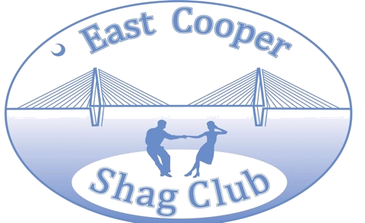
East Cooper Shag Club 2022 Membership Application

Memberships run from January 1 through December 31 each year. New Members $30/person. Renewals $25/person accepted until February 15th, 2022. If not renewed by that date, you are considered a new member at the cost of $30 per person
- Applications must be made for each individual member (couples must complete a separate application)
- Completed applications signify that each individual understands that dancing is an enjoyable event of one’s choosing and that ECSC and its board members have no liability for injuries sustained by dancers and that participation in any event is at one’s personal risk.

Unsigned applications will not be accepted or processed

Contact Information
Name (please print)
Street Address City ST ZipCode Home Phone Cell Phone
E--Mail Address Birth Mo. & Day

Renewals $25.00/person | New Members cost $30.00/person
 | Amount | Cash/check

Volunteers are needed to keep the club running. Please offer your time and volunteer. Please tell us where you would like to serve:

Please submit your application along with the appropriate fees to:
ECSC c/o
Lisa McCaskill
90 Vincent Dr.
Mt. Pleasant, SC 29464

*****Sign below - unsigned applications will not be accepted or processed*****
Signature (required)

